This documents the issues I found in the solution provided for Pandas HeroesOfPymoli

homework. The update code is in

HeroesOfPymoli-withGenderNAgeGroupCorrection.ipynb

**Error in solution:**

1. **Gender Demographics – provided solution is shown below:**

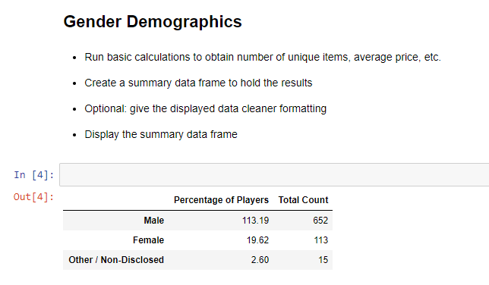

Excel used to calculate sum of Percentage of Players & sum of Total Count based on solution:

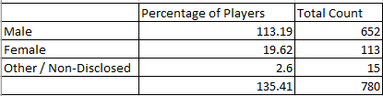

Further the sum of Percentage of Players in solution exceeds 100%. As a matter of fact, Male player percent alone exceeds 100%. This is because Percentage of Players in solution was calculated using Total count / 576 instead of 780. This makes no sense.

Unlike the Purchasing Analysis by Gender, the calculation for this analysis should take into account of the multiple purchases by some players, and based it on unique players of each gender.

The solution should look like this:

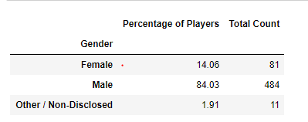

Excel below was used to calculate updated sum of Percentage of Players & Total Count. Now Total Count matches the total number of players, and the percentage adds up to 100%

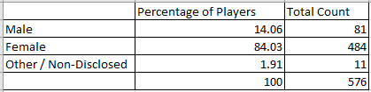

1. **Gender Demographics – Provided solution is shown below:**

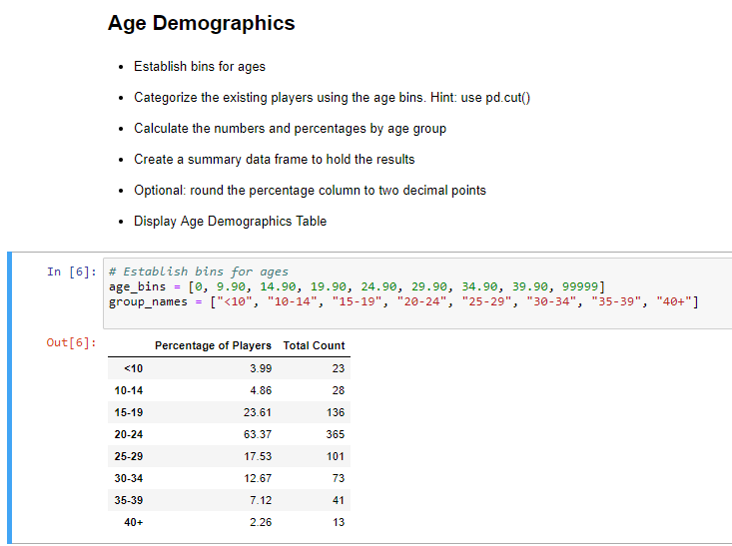

Excel used to calculate sum of Percentage of Players & sum of Total Count based on solution:

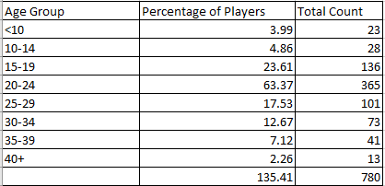

This is similar to the Gender analysis, except on Age Group. Like the Gender analysis, Total Count does not take into account of players with multiple purchases, but Percentage of Players is calculated using the distinct total number of players (576). And once again, the sum of Percentage of Players exceeds 100%.

Unlike the Purchasing Analysis by Age Group, the calculation should take into account of distinct players per Age Group, and perform the calculation consistently.

The solution should look like this:

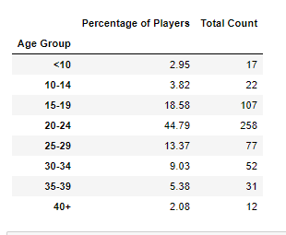

Excel below was used to calculate updated sum of Percentage of Players & Total Count. Now Total Count matches the total number of players, and the percentage adds up to 100%

